Computer Vision Homework 3

Oron Barazani 305295818 & Roee Hadar 206390098

Part 1:

1. 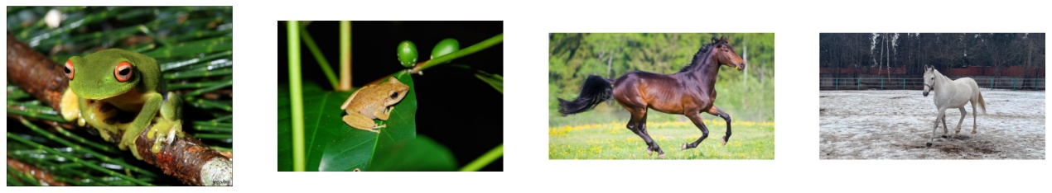The provided images:
2. 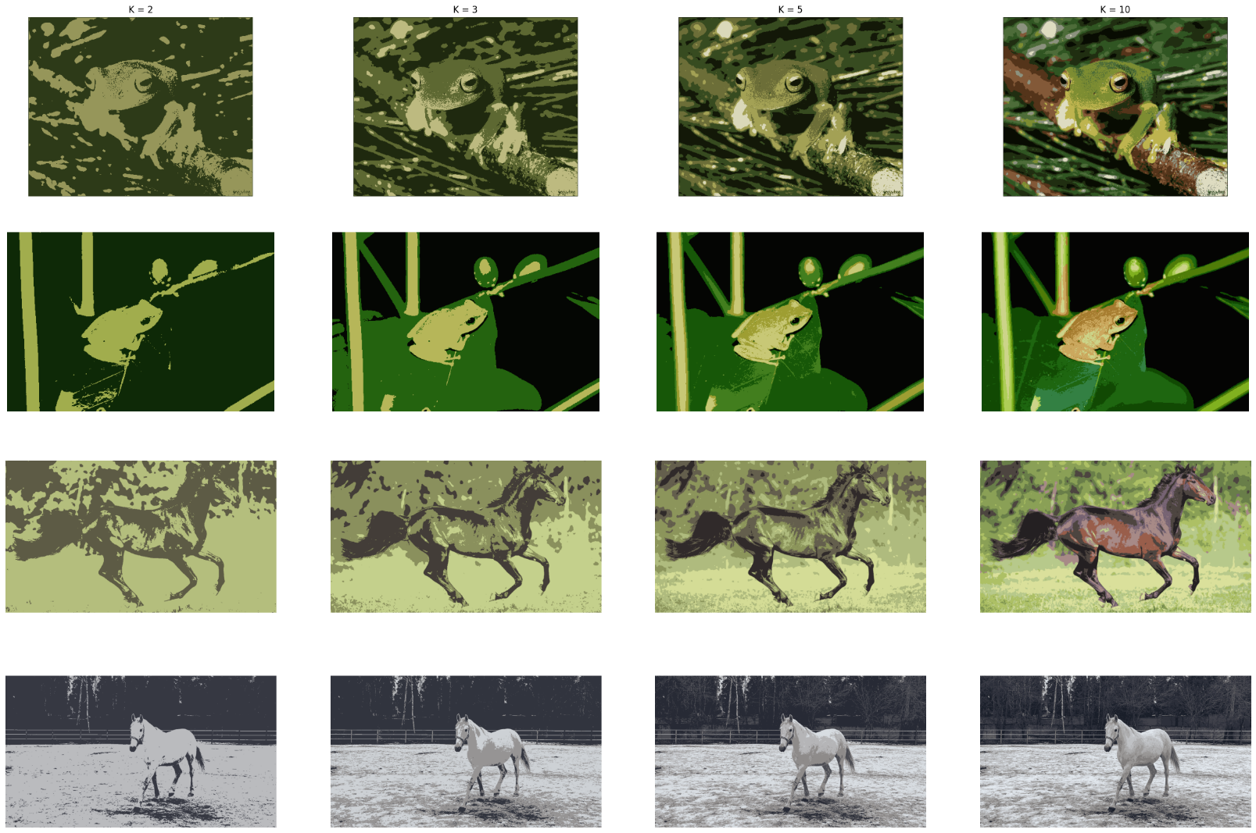Classic segmentation using K-means algorithm:

K-mean algorithm offer color intensity-based segmentation. Its advantage is in segmenting object which differs from their background by color – for the second frog image only 3 clusters needed for segmentation! And for the other frog and first horse 10 clusters offered fair result. The downside of this method is demonstrated in second horse image which is white on snowy background -

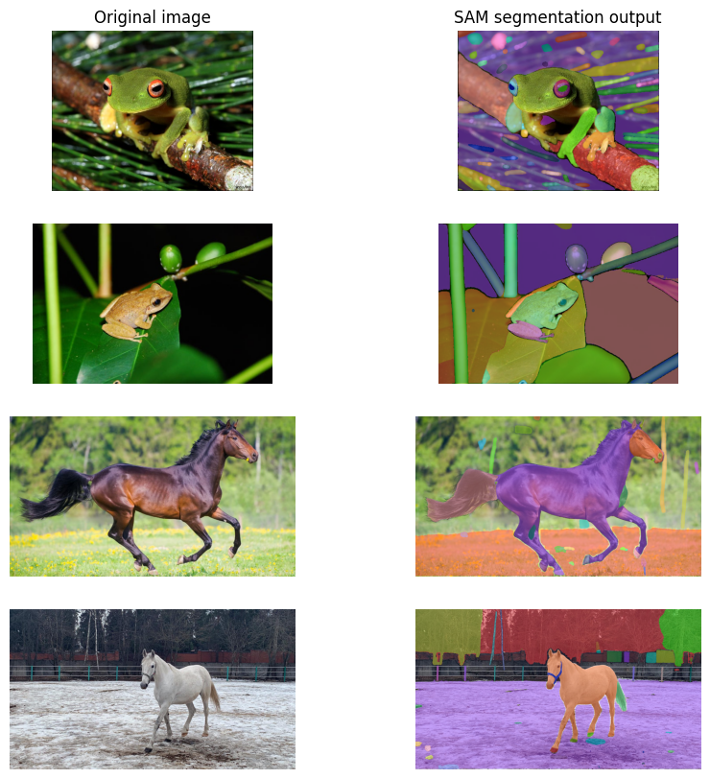And using DL model – SAM:

We can see that using SAM we got good segmentation result, and in some of the cases as in the first frog, the model segmented the image in excessive manner. Few blobs, that aren’t really an object are detected, and the same can be observed in the first horse image.

The strength of this model is demonstrated in second horse image, where k-Means struggled to segment correctly object from background. The horse is segmented completely off the background.

1. תמונה שמכילה טקסט, צילום מסך, בחוץ, חשבונייה

   התיאור נוצר באופן אוטומטיDisplay our images (a person, a car, an abacus):
2. תמונה שמכילה עץ, בחוץ, קולאז’, צילום מסך

   התיאור נוצר באופן אוטומטיK-means segmentation:

For the first two images the algorithm failed to segment the object correctly. In the first image, the person's shirt is similar in its color to the background and it hard to tell where the edge of the shirt is. In the second image (car), we expected for a good segmentation – red car on green-brown background, however the algorithm failed to create the car-reds cluster. Maybe higher number of cluster would have helped. For the third image (abacus) – we got excellent result for merely 5 clusters. The abacus beads have unique color that differ from the background, leading for good results – the problem is that each abacus row is segmented as a whole, and not separated beads.

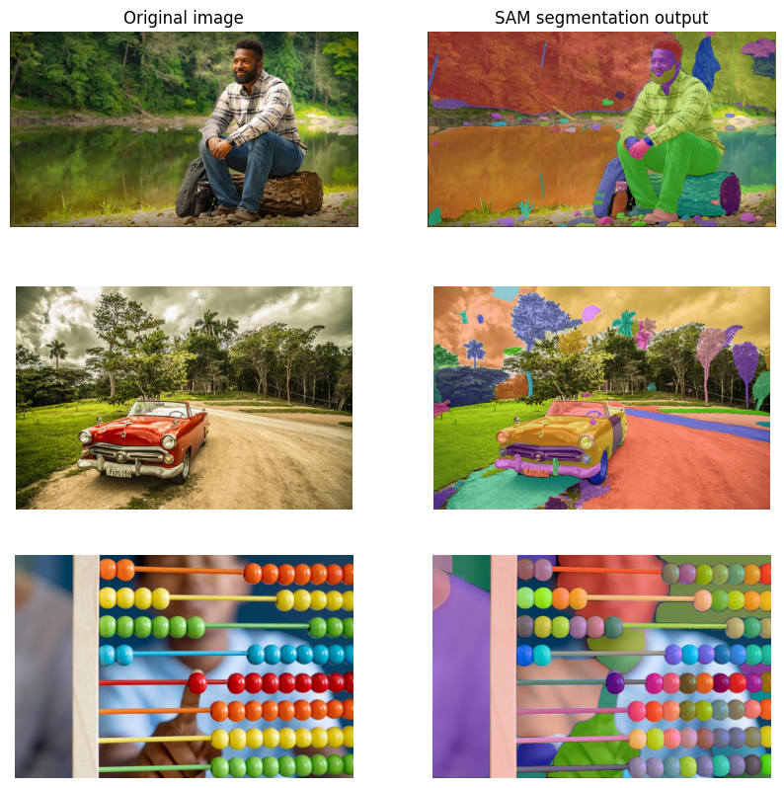

in SAM segmentation we got excellent overall results. In the person image we got different masks for the shirt and its background. The car image is also segmented correctly. In the last image the results are even better. The beads are segmented separately as opposed to k-means segmentation as mentioned above.